**Objective:** Apply *Method Overriding* concept.

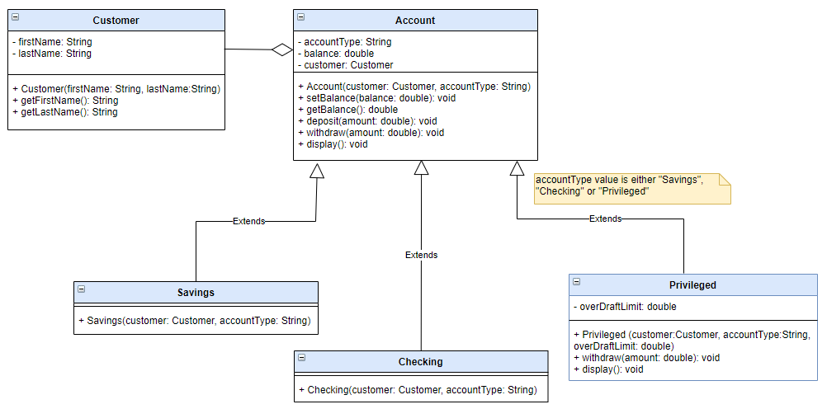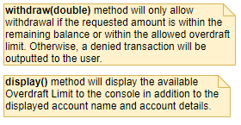

*Privileged Accounts are those accounts that allow overdraft limit.*

*Overdraft limit is the amount wherein the customer is allowed to withdraw even if the actual account balance is already zero.*

*Example:*

***Sample Output:***

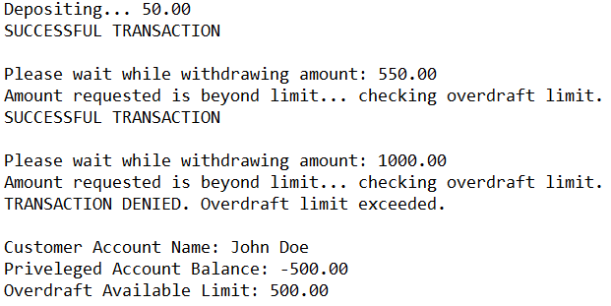

*Privileged account has a current account balance of 1000.00. And is allowed an overdraft limit of 5,000.00.*

*When account holder withdraws 2000.00, he will still be able to withdraw even if the account balance is only at 1000.00*

*That means the actual account balance will be -1000 and the overdraft limit will be deducted with 1000.00.*

*Making the overdraft limit now at 4000.00*

*Note: You may reuse the existing classes from previous exercise (Inheritance and Encapsulation)*

**Instructions:**

1.In your Java project, create your package.

2.Create a new class **Privileged** based on the UML Class Diagram. In the Privileged class, override the **withdraw()** method from the parent class such that it will only allow withdrawal if amount is within the remaining balance or within the allowed overdraft limit.

3.Override the **display()**method from the parent class to include the available **Overdraft Limit** in the console display.

4. Create new class **AccountMain** and perform the following:

-Create Customer object.

-Create instance of Privileged account with an overdraft limit of 1000.

* Deposit 50 to account.

* Withdraw 550.

* Withdraw again 1000.

* Display Privileged account details.